**Operator overloading**

**Q 1. What are the benefits and drawbacks of operator overloading?**

Answers: Benefits and Drawbacks of Operator Overloading:

Benefits

1. Natural Syntax: Allows using operators with user- defined types similarly to built-in types, enhancing readability and reducing verbosity.
2. Simplifies Code: Makes code concise and easier to understand, especially for mathematical or complex operations.
3. Maintains Consistency: Enables the use of intuitive operators for use of intuitive operators for custom types, maintaining consistency in coding style.

Drawbacks:

1. Potential of Misuse: Overuse or misuse of operator overloading can lead to code that is difficult to understand or maintain.
2. Semantic Clarity: Overload operators might not always carry their conventional meaning, which can confuse readers of the code.
3. Performance Implications: Incorrectly implemented operator overloads can impact performance negatively.

Q 2. Can you overload the assignment operator (=) in C++? If so, how would you ensure proper behaviour?

class MyClass {

public:

MyClass& operator=(const MyClass& other) {

if (this != &other) { // Self-assignment check

// Implement assignment logic here

}

return *this;

}

};

Key points for proper behaviour:

Self-assignment check: Always check if this pointer is equal to &other to avoid unnecessary work and potential issues.

Return reference to *this: Allows chaining of assignments (a = b = c;).

Q 3. Explain the difference between member function and non-member (friend) function overloading for operators.

**Answers**: Member Function vs Non-Member (Friend) Function Overloading

**Member Function Overloading:** Operators are overloaded as member functions of a class. They have access to the private members of the class directly.

**Non-Member (Friend) Function Overloading:** Operators are overloaded as non-member functions, often declared as friends of the class. They do not have access to the private members directly but can access them through public member functions.

**Q 4. Design a class Vector2D and overload the arithmetic operators (+, -, *, /) for vector addition, subtraction, scalar multiplication, and division (by a scalar).**

**Is it possible to overload the comparison operators (==, !=, <, >, <=, >=) for custom classes? If so, what considerations should be taken into account?**

**Can you overload the stream insertion (<<) and extraction (>>) operators for your Vector2D class to allow easy printing and reading from streams?**

**Describe a scenario where overloading the logical operators (&&, ||, !) for a custom class might be useful.**

Answer:

**Overloading Comparison Operators for Custom Classe**s

Yes, it is possible to overload comparison operators (==, !=, <, >, <=, >=) for custom classes in C++

• **Define Meaningful Semantics**: Ensure that the comparison operators have clear and meaningful semantics for your class. For example, when would two instances of your class be considered equal? What does it mean for one instance to be greater than another?

• **Maintain Consistency**: Follow standard conventions and ensure that the operators behave consistently with each other.

• **Const-Correctness**: Declare comparison operators as const member functions if they do not modify the internal state of the object. This adheres to the principle of not modifying objects during comparison operations.

• **Handle Type Compatibility**: Overload operators in a way that makes sense for the types involved. For example, if comparing two instances of your custom class, ensure the comparison logic is appropriate and well-defined.

• **Provide Correct Return Types**: Return bool from comparison operators to adhere to the expected behaviour of such operators.

#include <iostream>

class Vector2D {

private:

double x, y;

public:

Vector2D(double x = 0, double y = 0) : x(x), y(y) {}

// Overload + operator for vector addition

Vector2D operator+(const Vector2D& other) const {

return Vector2D(x + other.x, y + other.y);

}

// Overload - operator for vector subtraction

Vector2D operator-(const Vector2D& other) const {

return Vector2D(x - other.x, y - other.y);

}

// Overload * operator for scalar multiplication

Vector2D operator*(double scalar) const {

return Vector2D(x * scalar, y * scalar);

}

// Overload / operator for scalar division

Vector2D operator/(double scalar) const {

return Vector2D(x / scalar, y / scalar);

}

// Overload << operator for easy printing

friend std::ostream& operator<<(std::ostream& os, const Vector2D& vec) {

os << "(" << vec.x << ", " << vec.y << ")";

return os;

}

// Overload >> operator for easy input

friend std::istream& operator>>(std::istream& is, Vector2D& vec) {

is >> vec.x >> vec.y;

return is;

}

};

Q. Overloading Stream Insertion and Extraction Operators (<< and >>)

Yes, you can overload the stream insertion (<<) and extraction (>>) operators for your Vector2D class to allow easy printing to and reading from streams (like std::cout and std::cin)

#include <iostream>

class Vector2D {

private:

double x, y;

public:

Vector2D(double x, double y) : x(x), y(y) {}

// Overload stream insertion operator <<

friend std::ostream& operator<<(std::ostream& os, const Vector2D& vec) {

os << "(" << vec.x << ", " << vec.y << ")";

return os;

}

// Overload stream extraction operator >>

friend std::istream& operator>>(std::istream& is, Vector2D& vec) {

// Assuming input format is (x, y)

char discard;

is >> discard; // Read '('

is >> vec.x;

is >> discard; // Read ','

is >> vec.y;

is >> discard; // Read ')'

return is;

}

};

int main() {

Vector2D vec1(3.5, 2.8);

// Print Vector2D object using <<

std::cout << "Vector vec1: " << vec1 << std::endl;

Vector2D vec2(0.0, 0.0);

// Read Vector2D object from input using >>

std::cout << "Enter vector coordinates (x, y): ";

std::cin >> vec2;

std::cout << "Vector vec2: " << vec2 << std::endl;

return 0;

}

**Q . Discuss the potential ambiguity that could arise when overloading the subscript operator ([]) for a class. How can this ambiguity be resolved?**

When overloading the subscript operator ([]) for a class in C++, potential ambiguity can arise due to two main scenarios:

1. **Overloading for Different Purposes**: The subscript operator can be overloaded to serve different purposes depending on the class's design.
2. **Ambiguity in Argument Types**: C++ allows overloading based on the number and types of arguments. If you overload operator [] with multiple versions that differ only in the type or number of parameters, it can lead to ambiguity for the compiler to determine which version to call.

**Resolving Ambiguity in Overloading ‘operator []’**

To avoid ambiguity and ensure clarity in the use of operator[], you can follow these practices:

1.Consistent Use: Ensure that operator[] is used consistently for a single purpose within your class. If it's intended for accessing elements by index, stick to that purpose throughout the class's implementation.

2. Use const Correctly: Overload operator[] as const and non-const member functions if applicable. The const version should be used when the object itself is const and should not modify its state.

**Q. Can operator overloading be used to implement the concept of immutability (unchanging state) for a class? Explain your answer.**

Yes, operator overloading in C++ can be used to enforce immutability for a class.

In C++, you can overload operators as member functions or global functions. When designing an immutable class:

1. **Member Function Approach**: Define operators as member functions. Ensure that these functions do not modify the internal state of the object but instead return a new object with the desired operation's result.

class ImmutableNumber {

private:

int value;

public:

ImmutableNumber(int val) : value(val) {}

ImmutableNumber operator+(const ImmutableNumber& other) const {

return ImmutableNumber(value + other.value);

}

int getValue() const {

return value;

}

};

int main() {

ImmutableNumber num1(5);

ImmutableNumber num2 = num1 + ImmutableNumber(3);

std::cout << "num1 value: " << num1.getValue() << std::endl; // Output: num1 value: 5

std::cout << "num2 value: " << num2.getValue() << std::endl; // Output: num2 value: 8

return 0;

}

1. **Global Function Approach**: Overload operators as global functions to achieve similar immutability. Ensure that these functions do not modify their arguments but return a new object with the desired result.

class ImmutableNumber {

private:

int value;

public:

ImmutableNumber(int val) : value(val) {}

friend ImmutableNumber operator+(const ImmutableNumber& num1, const ImmutableNumber& num2) {

return ImmutableNumber(num1.value + num2.value);

}

int getValue() const {

return value;

}

};

int main() {

ImmutableNumber num1(5);

ImmutableNumber num2 = num1 + ImmutableNumber(3);

std::cout << "num1 value: " << num1.getValue() << std::endl; // Output: num1 value: 5

std::cout << "num2 value: " << num2.getValue() << std::endl; // Output: num2 value: 8

return 0;

}

**Q. When overloading operators, what are some best practices to ensure code clarity and maintainability?**

**• Follow Standard Conventions**: Stick to well-established conventions for operator behaviour.

• **Documen**t **Your Intentions**: Use comments to explain the purpose of each operator overload. Describe what the operator does and any assumptions or constraints it relies on.

• **Maintain Consistency**: Ensure that the behaviour of overloaded operators is consistent with their standard counterparts. Users should expect predictable behaviour based on established norms.

• **Handle Edge Cases**: Consider edge cases and unexpected input. Ensure your operators handle these gracefully or throw appropriate exceptions if necessary.

• **Use Const-Correctness**: Declare member functions that don't modify the object's state as const. This includes most operator overloads that return a new object rather than modifying the current one.

• **Overload Sensibly**: Avoid overloading operators in a way that makes your code difficult to read or understand. Overload operators where it makes logical sense and enhances

. • **Test Thoroughly**: Test your operator overloads thoroughly to ensure they behave as expected in all scenarios, including edge cases and various input types.

.• **Provide Clear Error Handling**: Handle errors or unexpected input gracefully. Return error codes or throw exceptions where appropriate to signal failure or incorrect usage.

**Q. What is the core concept behind function overloading?**

The core concept behind function overloading is to provide multiple functions with the same name but different parameter lists within the same scope. Function overloading allows you to define multiple functions with the same name but different signatures (different types and/or number of parameters).

Key Aspects of Function Overloading:

1. **Same Name, Different Parameters**
2. **Compile-Time Polymorphism**
3. **Improved Readability and Maintainability**:
4. **Convenience and Flexibility**.

**Q**. **How does the compiler differentiate between overloaded functions with the same name?**

The compiler differentiates between overloaded functions with the same name based on the number and types of arguments (parameters) provided when the function is called.

**Signature Matching**:

**Parameter Count**

**Type Matching**:

**Exact Match vs. Conversion**:

**Resolving Ambiguities**.

#include <iostream>

// Function overloading example

void print(int num) {

std::cout << "Printing integer: " << num << std::endl;

}

void print(double num) {

std::cout << "Printing double: " << num << std::endl;

}

int main() {

print(5); // Calls print(int)

print(3.14); // Calls print(double)

// Uncommenting the line below would cause ambiguity error

// print(5.0); // Ambiguous call: could be print(int) or print(double)

return 0;

}

Q. **Can functions with different return types be overloaded? Explain your reasoning.**

**Design a function printValue that can handle different data types (e.g., int, double, std::string) by overloading it with appropriate parameter lists.**

No, functions with different return types cannot be overloaded solely based on their return types. In C++ and many other programming languages, function overloading is based strictly on the function's signature, which includes the function name and the types (and order) of its parameters. The return type alone does not differentiate between overloaded functions.

Reasoning:

Function Signature

Return Type Ignored

Compile-Time Resolution

Designing printvalue function:

#include <iostream>

#include <string>

// Overloaded printValue functions for different data types

void printValue(int value) {

std::cout << "Printing integer: " << value << std::endl;

}

void printValue(double value) {

std::cout << "Printing double: " << value << std::endl;

}

void printValue(const std::string& value) {

std::cout << "Printing string: " << value << std::endl;

}

int main() {

printValue(5); // Calls printValue(int)

printValue(3.14); // Calls printValue(double)

printValue("Hello, World!"); // Calls printValue(const std::string&)

return 0;

}

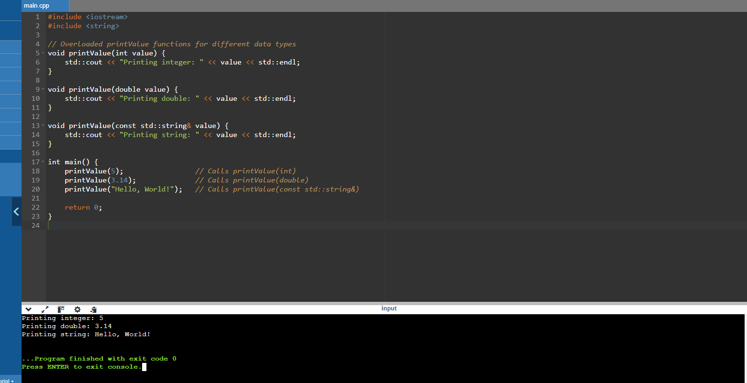

Q. Discuss the advantages and disadvantages of using default arguments in overloaded functions.

### Advantages:

1. **Reduced Number of Overloads**: Default arguments allow you to provide a single function declaration with default parameter values instead of multiple overloaded functions with different parameter lists.
2. **Improved Readability**: Default arguments can make function calls more readable by eliminating the need to explicitly pass values for parameters that commonly have default values.

**Disadvantages:**

1. **Potential Confusion and Ambiguity**: Default arguments can lead to confusion if not used carefully, especially when multiple overloaded functions are involved.
2. **Complicates Function Signatures**: Default arguments can complicate the function's signature, making it less explicit what parameters are required for different uses of the function.

**Q. In the context of function overloading, explain the concept of argument promotion and implicit type conversion.**

In the context of function overloading, argument promotion and implicit type conversion are important concepts that determine which overloaded function is selected by the compiler when a function is called with arguments of different types.

### Argument Promotion:

Argument promotion refers to the automatic conversion of function arguments to a "higher" or more general type in order to match the parameter type expected by the overloaded function. This typically happens when there is no exact match between the argument type and the parameter type, but there exists a standard conversion that can be applied without loss of information.

### Implicit Type Conversion:

Implicit type conversion (or implicit type coercion) involves the automatic conversion of one data type to another data type. This occurs when it is safe and meaningful to do so, typically without explicit indication from the programmer.

**Q . When might it be a better idea to use separate functions with descriptive names instead of overloading a single function?**

Using separate functions with descriptive names instead of overloading a single function can be a better approach in several scenarios where clarity, maintainability, or explicitness are prioritized:

1. **Distinct Functionality**
2. Complex or Specialized Logic
3. **Avoiding Ambiguity**:
4. **Clarity and Readability**:
5. Ease of Maintenance

**Q. Can function overloading be used to achieve polymorphism (the ability to treat objects of different derived classes in a similar way)? Explain**.

Function overloading in C++ is a feature that allows multiple functions with the same name but different parameter lists to coexist within the same scope. While function overloading is related to polymorphism, it is distinct from polymorphism achieved through inheritance and virtual functions (runtime polymorphism).

**Function Overloading**:

* **Compile-Time Polymorphism**
* **Static Binding**.
* **Same Function Name**
* void process(int num) {
* std::cout << "Processing integer: " << num << std::endl;
* }
* void process(double num) {
* std::cout << "Processing double: " << num << std::endl;
* }

**Polymorphism (Through Inheritance and Virtual Functions)**:

* **Runtime Polymorphism**
* **Dynamic Binding**
* **Derived Class Usage**.

class Shape {

public:

virtual void draw() {

std::cout << "Drawing shape" << std::endl;

}

};

class Circle : public Shape {

public:

void draw() override {

std::cout << "Drawing circle" << std::endl;

}

};

class Square : public Shape {

public:

void draw() override {

std::cout << "Drawing square" << std::endl;

}

};

**Q. Describe a scenario where overloading a function with a variable number of arguments (varargs) could be beneficial.**

### Logging Function with Varargs Overloading

Consider a logging utility function that needs to log messages of various types and formats to different destinations (e.g., console, file). Varargs overloading can be useful here to provide a single interface for logging different types of data with varying numbers of arguments:

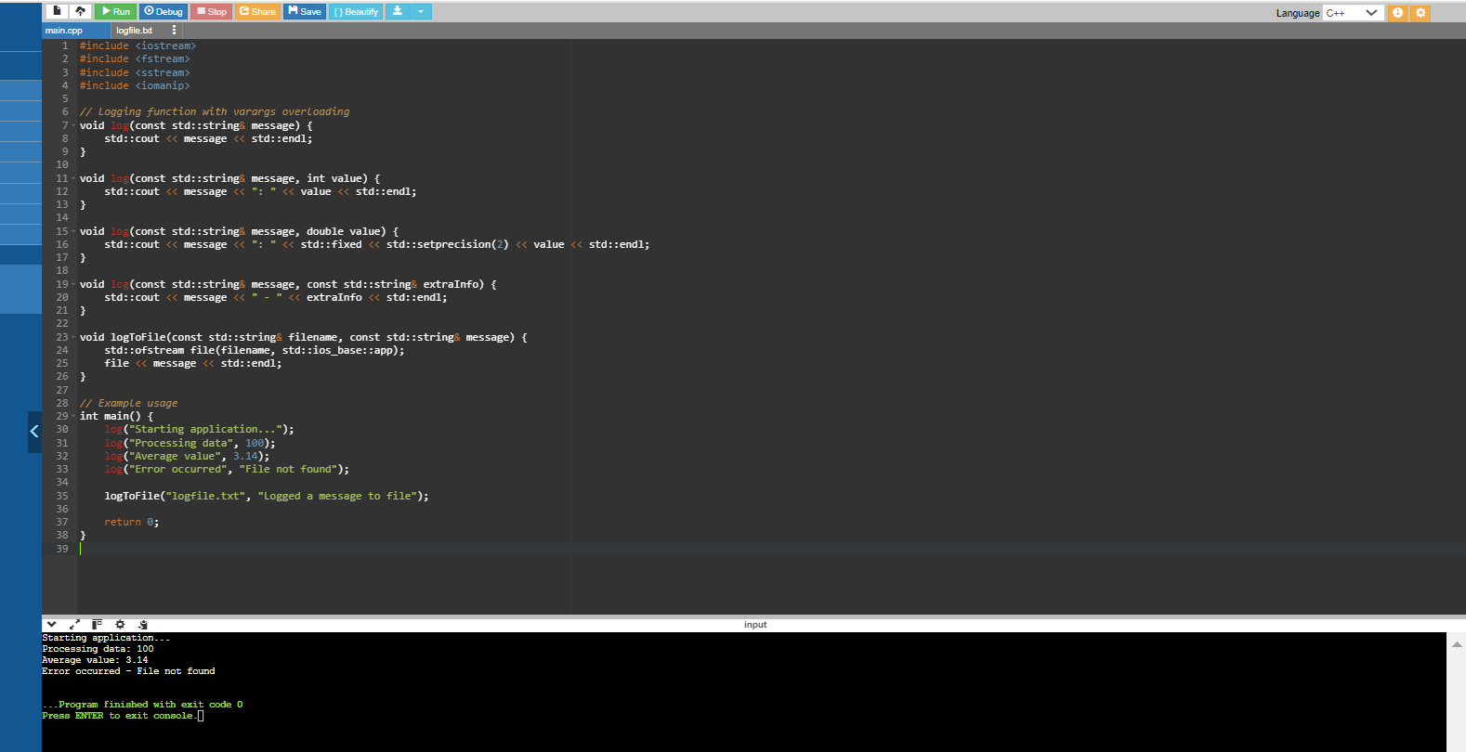

* **Multiple Overloaded Variants**:
* **Handling Different Types**
* **Varargs Benefits**
* **Extensibility**
* **Integration with File Logging**

In this scenario, varargs overloading simplifies the interface for logging messages with various content types and formats, enhancing flexibility and maintainability in logging functionality within the application.

Q. Compare and contrast function overloading with virtual functions in C++ inheritance. Which approach is more suitable for specific use cases?

Function overloading and virtual functions in C++ inheritance serve different purposes and are suitable for different use cases, depending on the design goals and requirements of your application.

**Function Overloading:**

**1.Purpose**:

* **Compile-Time Polymorphism**: Function overloading provides a way to define multiple functions with the same name but different parameter lists within the same scope.
* **Static Binding**: The specific function to be called is determined by the compiler based on the arguments passed at compile time.

**2**. • **Use Cases**:

* **Handling Different Argument Types**: Function overloading is useful when you want to provide multiple implementations of a function that operate on different types or numbers of arguments.
* **Enhancing Code Readability**: It improves code readability by allowing intuitive function names that reflect their intended operations.

Virtual Functions in C++ Inheritance:

**1.Purpose**:

* **Runtime Polymorphism**: Virtual functions enable polymorphic behavior, where the specific function to be executed is determined at runtime based on the actual object type.
* **Dynamic Binding**: The function call is resolved dynamically during runtime, allowing objects of different derived classes to be treated uniformly through base class pointers or references.

**2.Use Cases**:

• **Implementing Polymorphism**: Virtual functions are used to define a common interface in a base class that can be overridden in derived classes to provide specific implementations.

• **Enabling Object-Oriented Design Principles**: They facilitate principles like inheritance, abstraction, and polymorphism, allowing for more flexible and extensible code designs.

ChatGPT

Function overloading and virtual functions in C++ inheritance serve different purposes and are suitable for different use cases, depending on the design goals and requirements of your application. Here's a comparison and contrast of both approaches:

**Function Overloading:**

1. **Purpose**:
   * **Compile-Time Polymorphism**: Function overloading provides a way to define multiple functions with the same name but different parameter lists within the same scope.
   * **Static Binding**: The specific function to be called is determined by the compiler based on the arguments passed at compile time.
2. **Use Cases**:
   * **Handling Different Argument Types**: Function overloading is useful when you want to provide multiple implementations of a function that operate on different types or numbers of arguments.
   * **Enhancing Code Readability**: It improves code readability by allowing intuitive function names that reflect their intended operations.

**Virtual Functions in C++ Inheritance:**

1. **Purpose**:
   * **Runtime Polymorphism**: Virtual functions enable polymorphic behavior, where the specific function to be executed is determined at runtime based on the actual object type.
   * **Dynamic Binding**: The function call is resolved dynamically during runtime, allowing objects of different derived classes to be treated uniformly through base class pointers or references.
2. **Use Cases**:
   * **Implementing Polymorphism**: Virtual functions are used to define a common interface in a base class that can be overridden in derived classes to provide specific implementations.
   * **Enabling Object-Oriented Design Principles**: They facilitate principles like inheritance, abstraction, and polymorphism, allowing for more flexible and extensible code designs.

**Suitability for Specific Use Cases:**

* Function Overloading:
  + Suitable For: Handling different behaviours based on different argument types or numbers.
  + Advantages: Enhances code readability and simplicity for operations with varied parameters.
  + Limitations: Limited to static binding, which means decisions are made at compile time based on the function call context.
* Virtual Functions:
  + Suitable For: Enabling polymorphic behaviour across derived classes, where the behaviour can vary based on the actual object type.
  + Advantages: Supports runtime polymorphism, facilitating flexible and extensible designs through inheritance.
  + Limitations: Introduces overhead due to dynamic dispatch, which can impact performance in certain contexts.

Choosing Between Them:

* If your goal is to provide different implementations based on the types or number of arguments passed, function overloading is typically more appropriate due to its simplicity and compile-time resolution.
* If you need to model hierarchical relationships and polymorphic behavior across classes, virtual functions in inheritance are essential for achieving runtime polymorphism and treating objects of different derived classes uniformly through base class interfaces.